**Steady State Error Analysis**

**using Simulink**

**Lab: 09**



Fall 2022

CSE-3L Control Systems

Submitted by: **Amir Suliman**

Registration No: **19PWCSE1805**

Class Section: **B**

“On my honor, as a student of the University of Engineering and Technology, I have neither given nor received unauthorized assistance on this academic work.”

Student Signature: ______________

Submitted to:

**Dr: Muniba Ashfaq**

January 11, 2023

Department of Computer Systems Engineering

University of Engineering and Technology, Peshawar

**Objectives:**

* To know about steady-state error.

**Tasks:**

Setup negative feedback system for the following system:

**G(s) = k(s+6) / (s+4) (s+7) (s+9) (s+12)**

**H(s) = 1**

Plot on one graph the error signal for

1. Input = 5u(t) with k = 5,10,50,500,5000

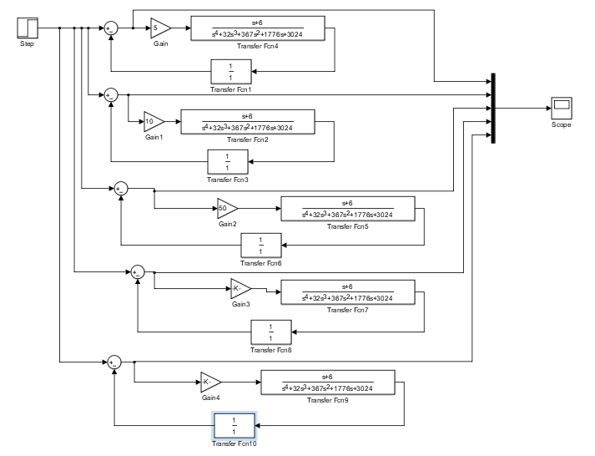

**Output:**

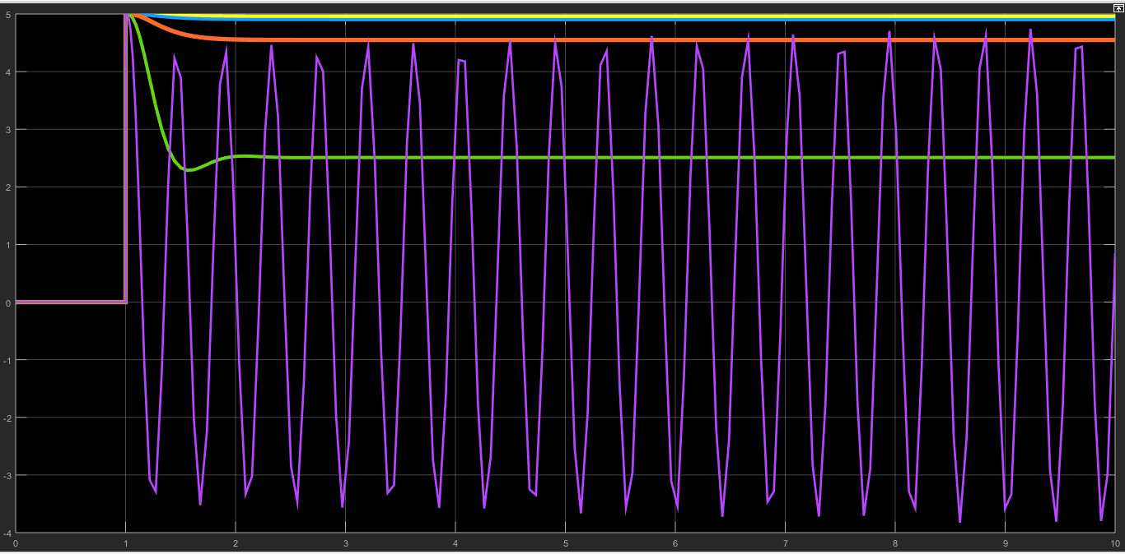

**Task 02:**

1. Input = 5tu(t) with k = 5,10,50,500,5000

**Simulink Design:**

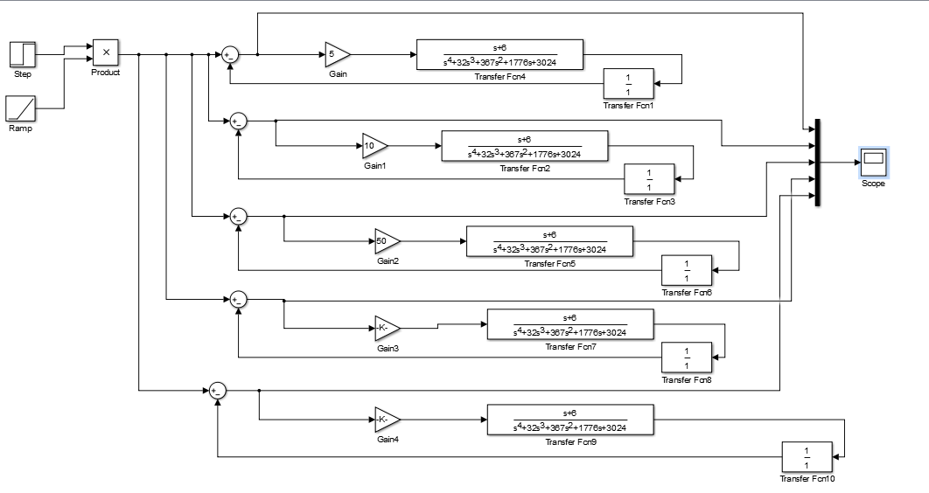

**Output:**

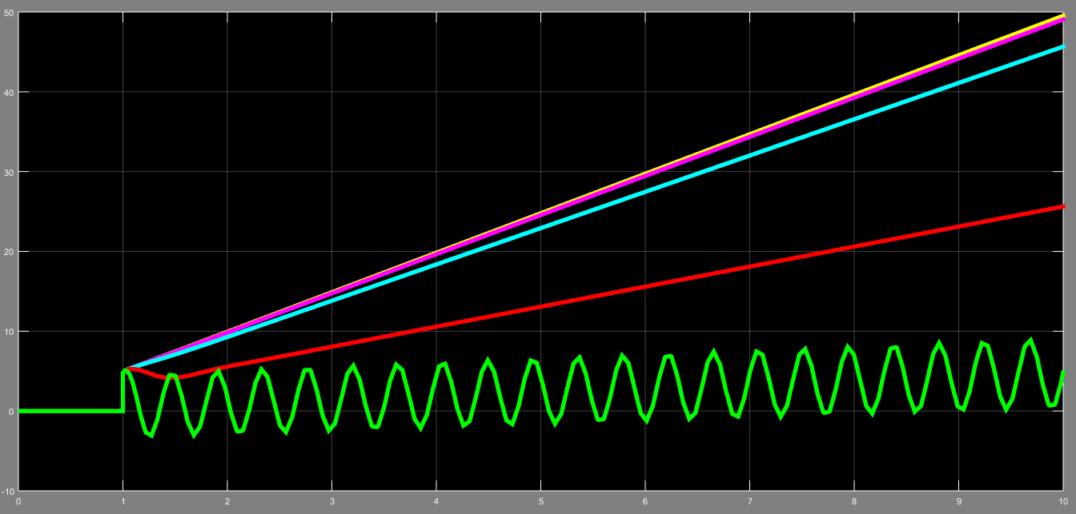

**Task 03:**

1. Input = 5t^2u(t) with k = 5,10,50,500,5000

**Simulink Design:**

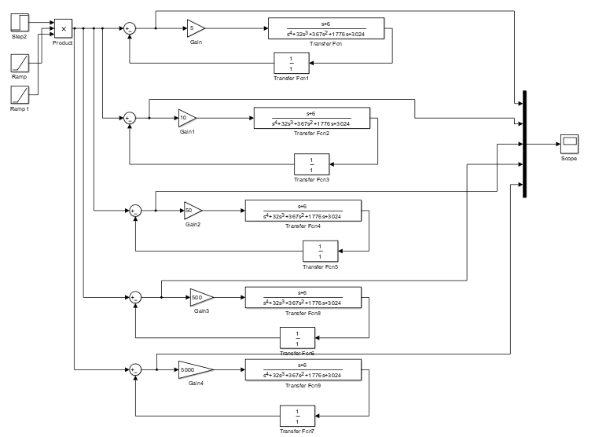

**Output:**

